Stop smoking
Avoid the willpower trap by using skill power
www.skillpower.co.za

YOUR FREE SMOKE-DIARY

Congratulations on your attempt to quit smoking. This diary has been designed to recognize your own set of behaviors to help you devise your strategies to target each behavior: Complete your smoke-diary by answering the following questions.

- How did you learn to smoke?

Think about what influenced you to smoke?
The purpose of this question is to take you back to the day when you lit your first cigarette. Remember that one cigarette was a lifetime of smoking -it was not just one cigarette. See that one cigarette as one hundred thousand or two hundred thousand cigarettes.

- Rate your motivation to quit smoking? (place an X )
Not Motivated Somewhat Motivated Motivated Highly Motivated

This self-assessment is to get a sense of where you are in your motivation and commitment to quitting smoking. This exercise is to help you to strengthen and sustain your motivation. Revisit this motivation score anytime you feel that you need a little psychological "boost" to remind you why you are going to all of this trouble to quit.

- How many times have you tried to quit smoking
☐Did not try to quit (skip question 4)
☐1-5 times
☐10+ times
90% of smokers relapse when they are trying to quit. The reason being is that they don't plan
adequately for the sources that influence their behavior. Next time when you relapse, identify what influenced you to light up again.

- If you tried to quit, which methods did you use
☐ Willpower method / cold turkey
Nicotine replacement therapy
☐ Gum ☐ Patches ☐ Lozenges ☐ Inhaler ☐ Spray
☐ Drugs such as Zyban or Chantix, etc ☐ Other (specify)____________________

There is no magic pill or a silver bullet to stopping smoking. Skillpower helps you see smoking from a different perspective and enables you to make a permanent decision to stop smoking. Don’t just rely on one strategy and expect to win. Plan for all your sources that influence your smoking

- At what age did you start smoking?

- How many years are you smoking?
(q5 and q6 help you determine how much time you have spent supporting your smoking life – you already know it costs you a fortune. A pack a day smoker spends an average time of 2-3 hours a day supporting his smoking behavior. If he smoked a pack a day for 20 years =14600 – 21900 hours lost over 20 years)

- Below is a 24-hour smoke-diary to identify your smoking behavior.

Steps to complete the diary
- Complete your smoke diary for a minimum of 3 days and a maximum of 7 days. Use the guide example below labeled - Example of a complete smoke diary for a given day.
- After each day, summarise your data in the table labeled “summary report.”
- After completing the summary report - group your sources of influence to smoke into your personal, social, and environmental influences in the final table.
- Now you have your blueprint to guide you and target each source of influence to smoke.

Below is an example of how to complete the smoke diary
Example of a complete smoke diary for a given day
Time | No of cigarettes/vapes consumed | Did you have any Cravings? Y / N | Comments (Where are you? What are you doing? Who is with you? What are you thinking about, and how are you feeling?
00h00 |  |  | Asleep
01h00
02h00
03h00
04h00
05h00
06h00 |  |  | Asleep
07h00 | 1 | Y | Alone, bathroom, tired, thinking about changing career
08h00 | 2 | Y | After breakfast, on my way to work in care, planning my day for work
09h00 | 1 | Y | With coffee at work with friends, talking about soccer, and looking for a new job
10h00
11h00
12h00 | 1 | Y | Work, with Allan and Jenny, boss stressed about deadlines to deliver a report by the end of the week
13h00 | 2 | Y | After a meal at work with Allan and Jenny, talking about the report
14h00
15h00 | 2 | Y | With coffee at work with other friends (non-smokers) talking about the report
16h00
17h00 | 1 | Y | in carpark with friends, talking about changing jobs, angry, taking work home almost every day
18h00 | 1 | N | At home in the bathroom, bored
19h00 | 2 | Y | After dinner, outside on my porch, relaxing. alone
20h00 | 2 | Y | At home in front of my PC, alone, exhausted
21Hoo
22h00 | 2 | Y | At home in front of my PC, bored
23h00 | 1 | N | Brush teeth, in the bathroom, go to bed, exhausted
24h00 |  |  | Asleep
Total | 19

Day 1 24-hour smoke diary
Time | No of cigarettes  /vapes consumed | Did you have any Cravings? Y / N | Comments (Where are you? What are you doing? Who is with you? What are you thinking about, and how are you feeling?
00h00
01h00
02h00
03h00
04h00
05h00
06h00
07h00
08h00
09h00
10h00
11h00
12h00
13h00
14h00
15h00
16h00
17h00
18h00
19h00
20h00
22h00
21hoo
23h00
24h00

Day 2: 24-hour smoke diary
Time | No of cigarettes  /vapes consumed | Did you have any Cravings? Y / N | Comments (Where are you? What are you doing? Who is with you? What are you thinking about, and how are you feeling?
00h00
01h00
02h00
03h00
04h00
05h00
06h00
07h00
08h00
09h00
10h00
11h00
12h00
13h00
14h00
15h00
16h00
17h00
18h00
19h00
20h00
22h00
21hoo
23h00
24h00

Day 3: 24-hour smoke diary
Time | No of cigarettes  /vapes consumed | Did you have any Cravings? Y / N | Comments (Where are you? What are you doing? Who is with you? What are you thinking about, and how are you feeling?
00h00
01h00
02h00
03h00
04h00
05h00
06h00
07h00
08h00
09h00
10h00
11h00
12h00
13h00
14h00
15h00
16h00
17h00
18h00
19h00
20h00
22h00
21hoo
23h00
24h00

Day 4: 24-hour smoke diary
Time | No of cigarettes  /vapes consumed | Did you have any Cravings? Y / N | Comments (Where are you? What are you doing? Who is with you? What are you thinking about, and how are you feeling?
00h00
01h00
02h00
03h00
04h00
05h00
06h00
07h00
08h00
09h00
10h00
11h00
12h00
13h00
14h00
15h00
16h00
17h00
18h00
19h00
20h00
22h00
21hoo
23h00
24h00

Day 5: 24-hour smoke diary
Time | No of cigarettes  /vapes consumed | Did you have any Cravings? Y / N | Comments (Where are you? What are you doing? Who is with you? What are you thinking about, and how are you feeling?
00h00
01h00
02h00
03h00
04h00
05h00
06h00
07h00
08h00
09h00
10h00
11h00
12h00
13h00
14h00
15h00
16h00
17h00
18h00
19h00
20h00
22h00
21hoo
23h00
24h00

Day 6: 24-hour smoke diary
Time | No of cigarettes  /vapes consumed | Did you have any Cravings? Y / N | Comments (Where are you? What are you doing? Who is with you? What are you thinking about, and how are you feeling?
00h00
01h00
02h00
03h00
04h00
05h00
06h00
07h00
08h00
09h00
10h00
11h00
12h00
13h00
14h00
15h00
16h00
17h00
18h00
19h00
20h00
22h00
21hoo
23h00
24h00

Day 7: 24-hour smoke diary
Time | No of cigarettes  /vapes consumed | Did you have any Cravings? Y / N | Comments (Where are you? What are you doing? Who is with you? What are you thinking about, and how are you feeling?
00h00
01h00
02h00
03h00
04h00
05h00
06h00
07h00
08h00
09h00
10h00
11h00
12h00
13h00
14h00
15h00
16h00
17h00
18h00
19h00
20h00
22h00
21hoo
23h00
24h00

- Summarizing your data
Upon completion of your 24-hour smoke-diary, summarize your data in the table below. This summary report is your blueprint for quitting. The summary will help you identify your personal, social, and environmental influences that trigger your smoking behavior. Relapses occur because of poor planning for the triggers and influences.
Table: Summary report
 | Day 1 | Day 2 | Day 3 | Day 4 | Day 5 | Day 6 | Day 7 | Total | Average
Total Cig
Cravings Yes
Cravings No
Total sleep
Where are you
What are you doing
Who is with you
How are you feeling
What are you thinking about

- Using the data from your summary table, group your information into personal, social, and environmental levels in the table below under the column titled your sources of influence. I have included some of the most common sources of influence under the column titled “Common sources of influence.” Sometimes your sources may overlap between the three levels of personal, social, and environmental. e.g., the smell of cigarettes can be a personal or environmental influence. Don’t be too concerned with the overlaps
Sources of influence or triggers to smoke
Levels | Common sources of influence | Your sources of influence
Personal source of influence (self-influenced behavior) | - After a meal  - When you wake up from asleep  - With coffee  - Stress/anxiety relief  - Aids concentration  - Relaxation  - Boredom  - Grieving
Social influences– with people | - Social occasion- lunch, coffee, party, hanging out with friends  - An argument with a partner, friend, family, or relative
Environment influences – places and things | - Smoking areas (home, work, public space)  - Smell/odor  - Advertising (movies, TV, seeing people smoke)  - paraphernalia (ashtrays, lighters, etc.)

How to avoid the willpower trap
Now that you have completed your sources of influence to smoke. Ask yourself this question

Why do you want to stop smoking?
Typical answers are: health, money, social stigma, odor

Smokers don’t have a willpower problem; they have a math problem to solve. Smokers are blinded and outnumbered by falling into the willpower trap. If they can control the sources that influence them, they are more likely to control their behavior.

Let’s pretend that you are smoking your final cigarette, and when you put it out, you are now a non-smoker using willpower. The problem is that you believed that the cigarette gave you something (as identified in your smoking diary) and now you are depriving yourself and you feel empty inside. So long as you feel deprived and empty, you are going to feel miserable and vulnerable. As soon as you encounter one of your triggers (sources of influence), you are going to have a desire to smoke. You are going to have to use willpower to overcome this desire. This creates conflict. Part of you wants to smoke and the other part does not want to smoke, and this conflict leads to feelings of panic, anxiety, anger, irritability and depression. Ironically, it is not physical withdrawal that creates these symptoms, its CONFLICT in our mind.

You need to remove the conflict, and by removing this conflict you will remove the symptoms of anger, frustration, anxiety, irritability and so forth. Every smoker has a game of tug-of-war being played out in their mind.

On the one hand, it is pulling you in one direction – it is killing me, it is costing me a fortune – you know, all those worries that come with smoking. On the other hand, pulling you in the opposite direction, there is this perceived benefit, this pleasure, this reward. But think about it for a second: these “benefits” of smoking are thinly disguised fears. The fear that you will not be able to relax, the fear that you will not be able to concentrate, the fear that you will not be able to cope with stress. It is the fear that you will not be able to cope with life without cigarettes.

When you look at your sources of influence that trigger your smoking behavior on a personal, social and environmental level, you see clearly how people fall into this willpower trap. They do not consider how are they going to overcome these trigger situations. Once you take control of the things that control you, it becomes easier to manage your withdrawal and cravings.

If you completed the exercises, it would demonstrate this clearly, to show you how blind and outnumbered you are when you use willpower. Willpower merely addresses the reasons why you should stop smoking and not the reasons why you smoke. To be successful, smokers need to address each of their beliefs about smoking. Willpower alone cannot help unless you address the sources that influence your behavior.

You can get more information on the common beliefs and misconceptions, the process of nicotine addiction, and more about your personal, social and environmental influences. It's all in the book below.

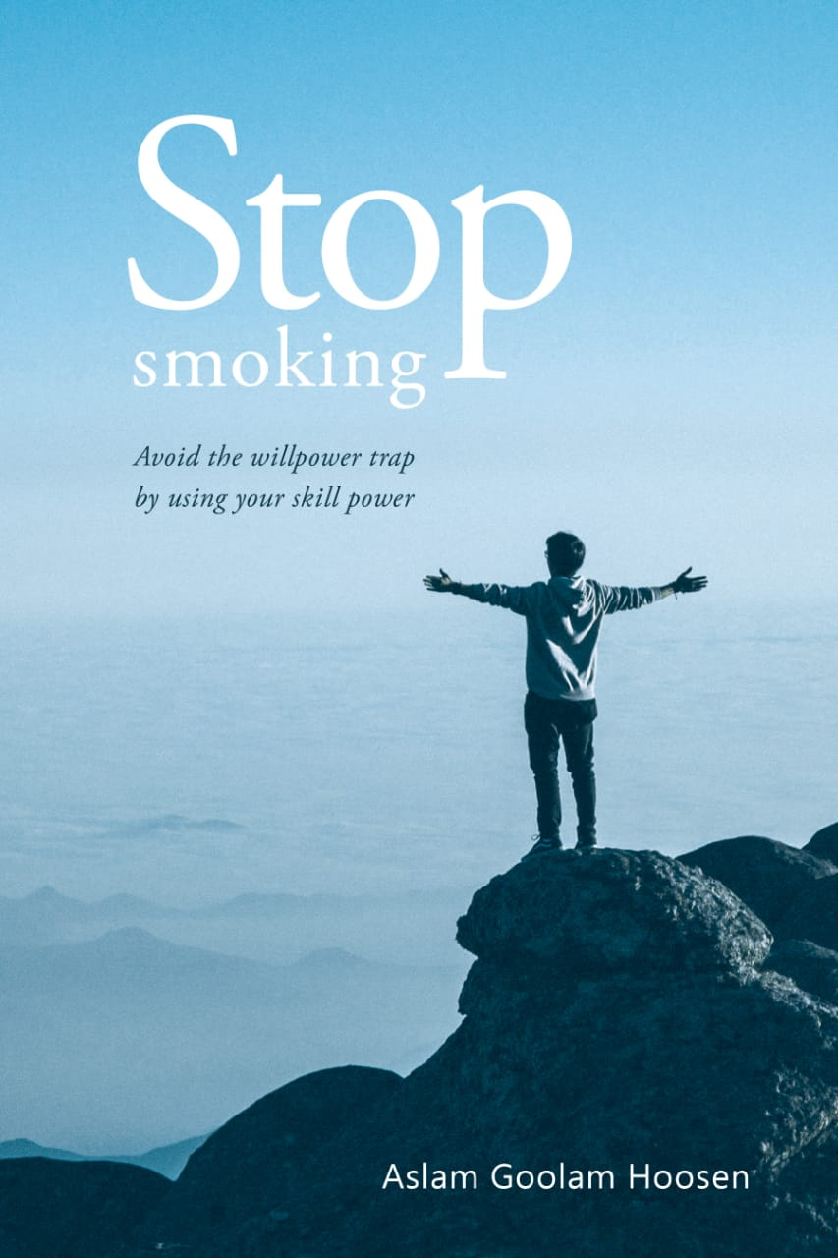

www.skillpower.co.za

Available on Amazon and Smashwords
from 25th Dec 2020

